**Synopsis**

**On**

**Voice Communication**

**Using Laser Light Transmission**

**Introduction:-**Laser communications systems are wireless connections through the atmosphere. They work similarly to fiber optic links, except the beam is transmitted through free space. While the transmitter and receiver must require lineof- sight conditions, they have the benefit of eliminating the need for broadcast rights and buried cables. Laser communications systems can be easily deployed since they are inexpensive, small, low power and do not require any radio interference studies. The carrier used for the transmission signal is typically generated by a laser diode.

Laser communications is a good solutions for how to satisfy ever increasing bandwidth demand. One solution is to use laser communication systems on top of homes and pointing them towards a common transceiver with a fast link to the Internet. With possible transmit speeds of up to a gigabit per second.

**Applications:-**

1. Radio Frequency transmission is widely used for wireless transmission worldwide. But it has two drawbacks.

(a)It transmits in omni direction, so the information can be intercepted by any receiver.so its risky to use RF transmission for secret information transmission.

Laser transmission is point to point transmission. Its beam is very thin and it is impossible to intercept it. It’s a safe type of transmission for wireless communication.

(b)RF Transmission requires bandwith allocation. Bandwith is limited so the no of channels available are also limited. Laser communication can be used to fulfill the ever increasing demand of channels.

**Laser Transmitter:-**

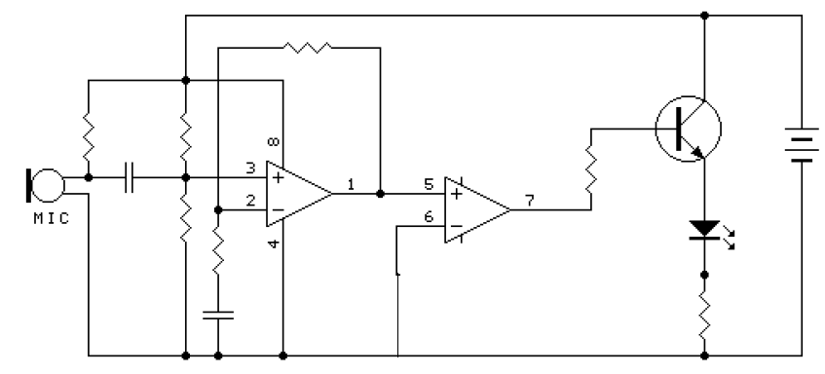

**Laser Receiver:-**

